Experiment 7
7. Execute and display the results for the following commands in Kali Linux Operating Systems:
i) cd ii) cp iii) ls

Aim: To execute and study the cd, cp, and ls commands in Kali Linux Operating System and observe their outputs.
i) cd Command
Command:
cd /home/kali
pwd
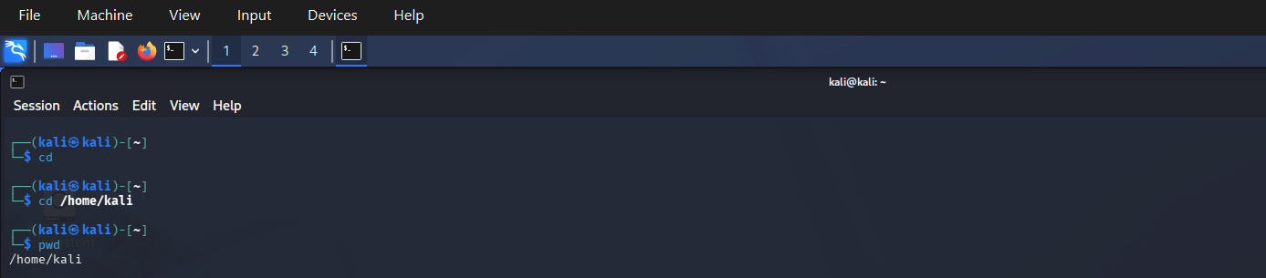
Explanation
The cd command stands for Change Directory. It is used to move from one directory to another.
Here, cd /home/kali changes the current directory to /home/kali. The pwd command displays the current working directory.

Expected Output
/home/kali
ii) cp Command
Command:
touch file1.txt
cp file1.txt file2.txt
ls
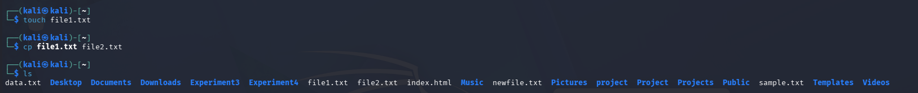
Explanation
The cp command stands for Copy. It is used to copy files or directories.
- touch file1.txt creates an empty file named file1.txt.
- cp file1.txt file2.txt copies the contents of file1.txt into a new file named file2.txt.
- ls displays the files in the current directory.
Expected Output
Your directory listing should include both files:
file1.txt file2.txt
Other files may also appear in the output.

iii) ls Command
Command:
ls
Explanation
The ls command stands for List. It displays the names of files and directories in the current working directory.
Expected Output
file1.txt file2.txt
Other files and directories may also be displayed, depending on your Kali Linux system.
Result: Thus, the cd, cp, and ls commands were successfully executed in Kali Linux Operating System, and their outputs were displayed and verified.

